Design Diagram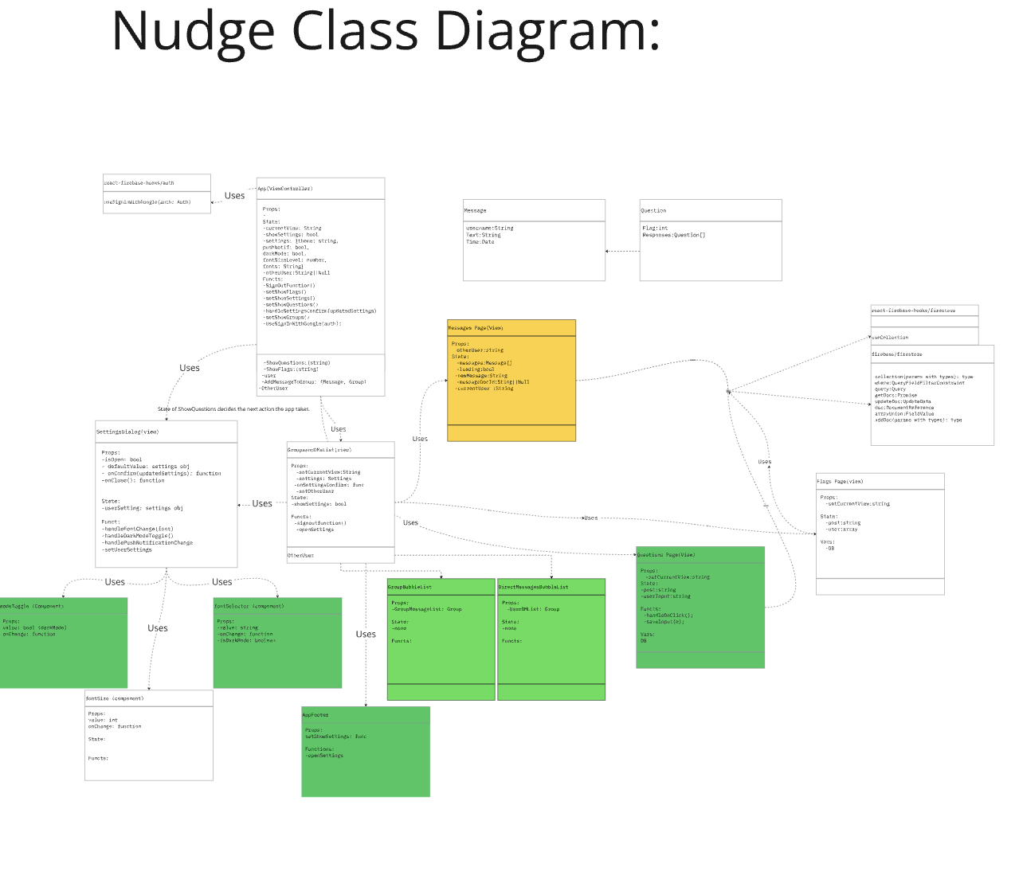

Team C: Class Diagram Miro Chart

Design Patterns

Strategy

In our program state switching is a key component to our app, as our states allow us to navigate through major features. Since are states are going to be reasonably high, and these states should change as frequently, the state design pattern is a good match. By using conditional statements we can use our state to act as a lock to different visuals or functions that require previous action. Though having many states in conditional statements can cause problems due to it being confusing to navigate very many nested states, the relatively simple navigation of our app should allow us to use states to navigate efficiently. This method also allows us to keep certain components on the screen while changing only the portion influenced by the state, and with that portion being potentially radically different the compartmentalization of the strategy pattern ensures each state change will minimally impact the rest of the view.

Our program specifically utilizes states such as “const [showQuestions, setShowQuestions] = useState(false);” To allow us to enter our questions page from our center hub of recent interactions. Also the states “const [userInput, setuserInput] = useState(String);, “and “const [Post,setPost] = useState([]);” are used in the message posting feature to save active user input, then save, and map the userInput into a displayed array.

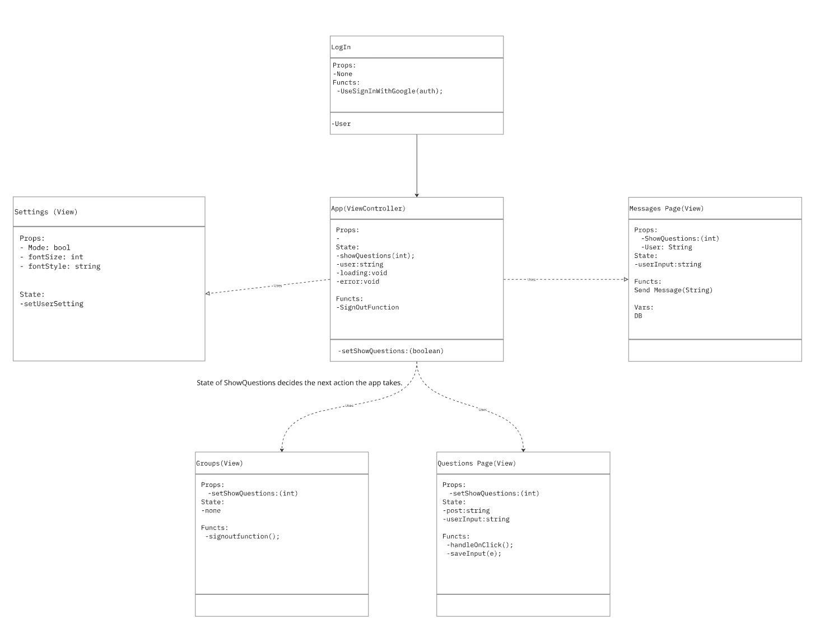
DCD Link(Note this diagram is a small subsection next to our DCD)
Here you see how from our primary app view controller the state of setShowQuestions, which is controlled by the clicking of the view questions tab in the header, will decide what view is currently displayed after signing in and how when the state changes another view can easily take its place.
